ASSIGNMENT ON BILLING

Task-1 : Create a billing alarm on your account to check if your account billing exceeds $1 for the current month.

Stepwise solution:

Step1: first of all, open the budgets and then go to create a budget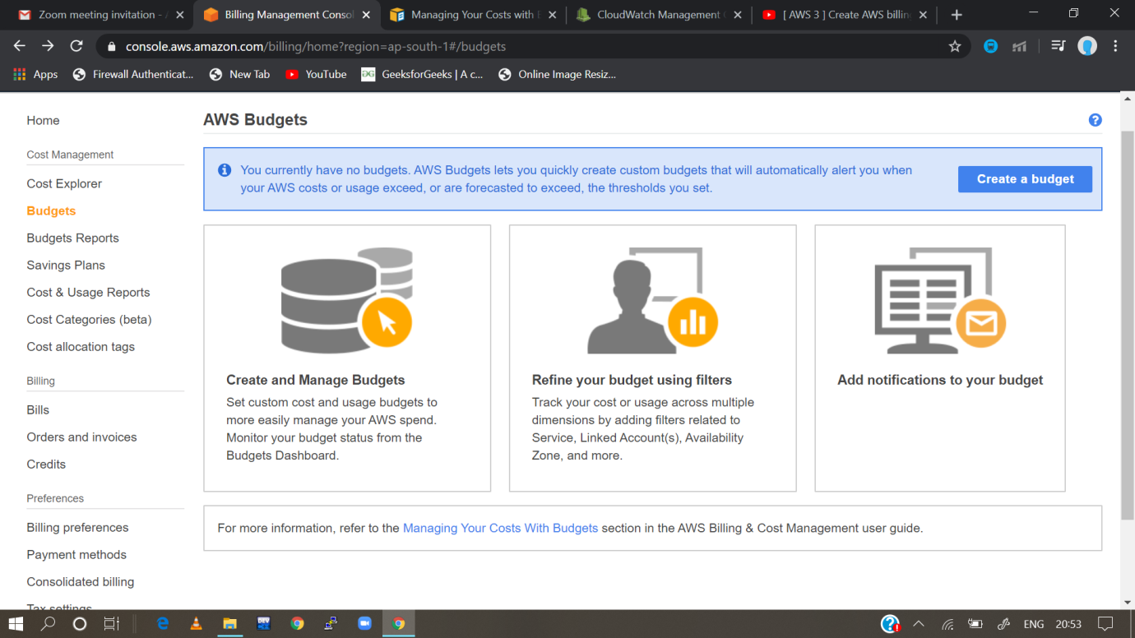

Step-2:then configure all the requirements

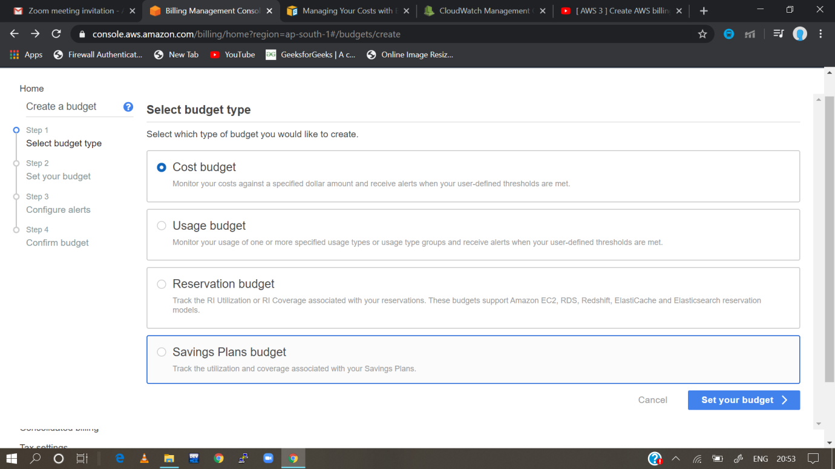Step-3

Step-3:then set your budget

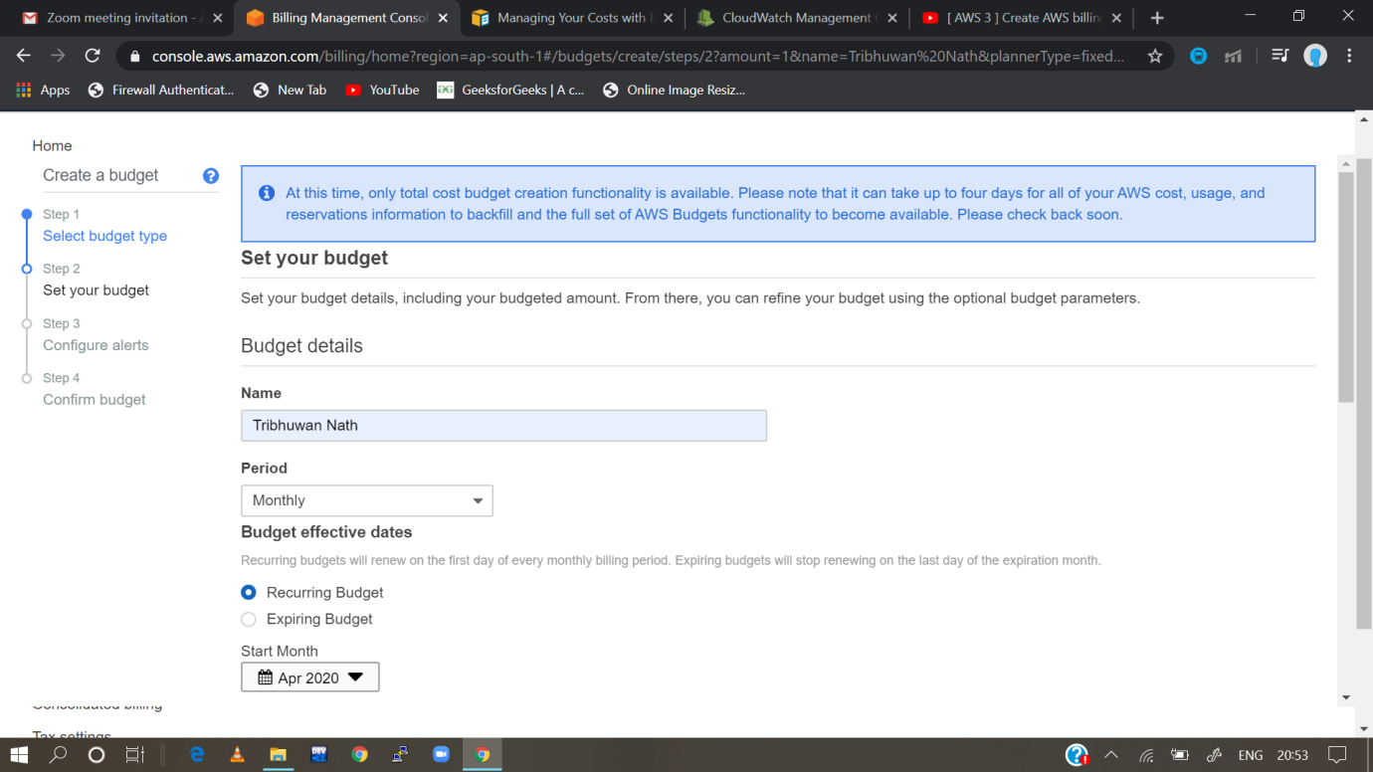

Step-4:then move to the next configuration and go to configure alerts*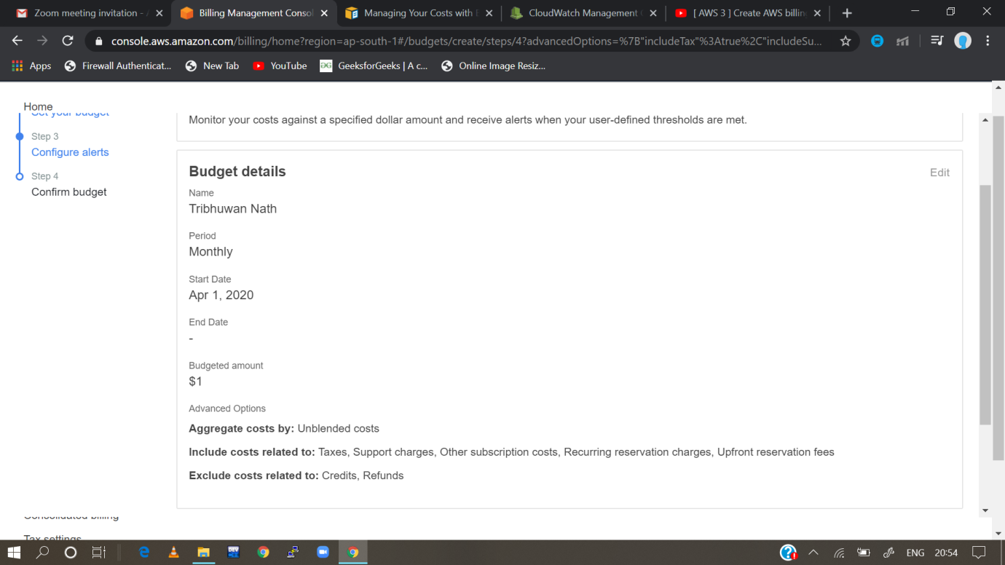*

Step-5: Hence we are able to set the alarm when it exceeds 1$. 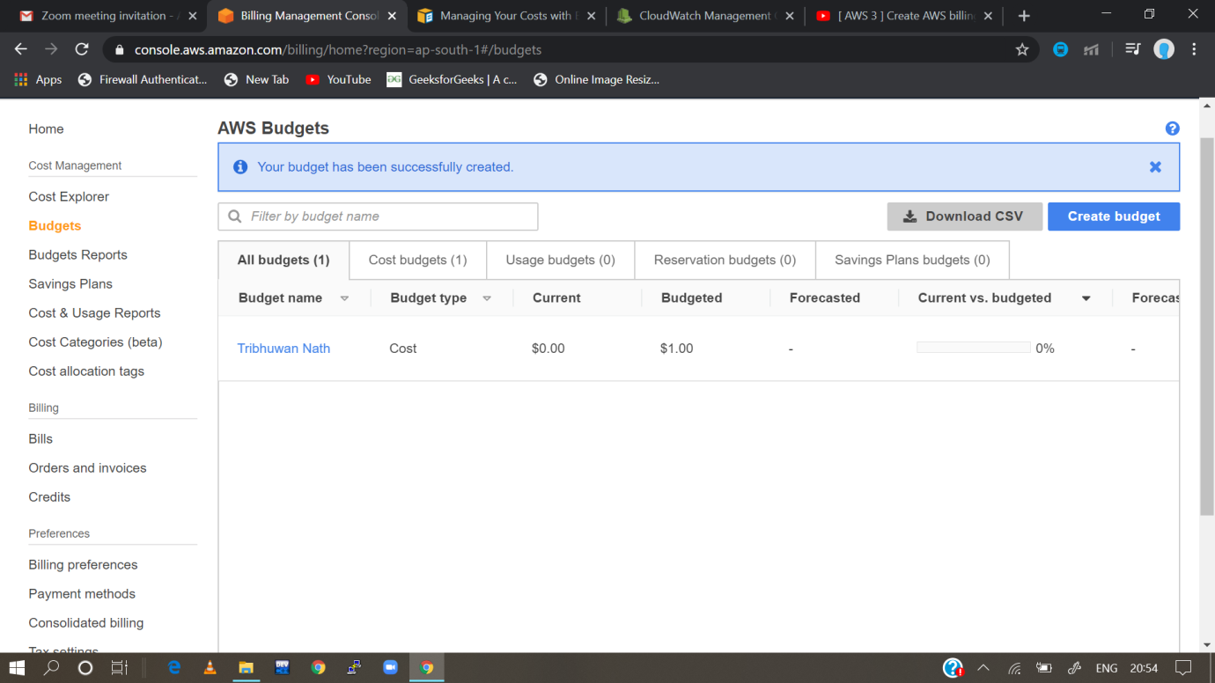

Assignment-2

Task-2:  Create an alarm on EC2 instance, to notify you if the instance is in stopped state or terminated state.

Steps:

Step-1: Create an instance

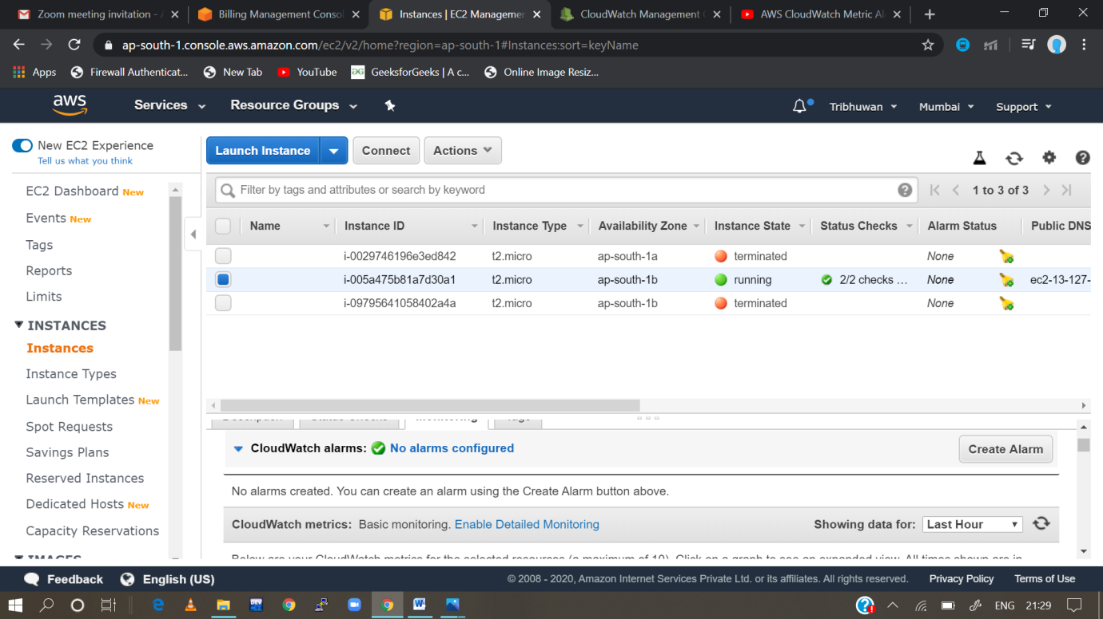

Step-2: then go to monitoring and check cloud watch alarms and go to “No alarms configured”

Step-3: then go to create alarm

Step-4 configure the alarm settings

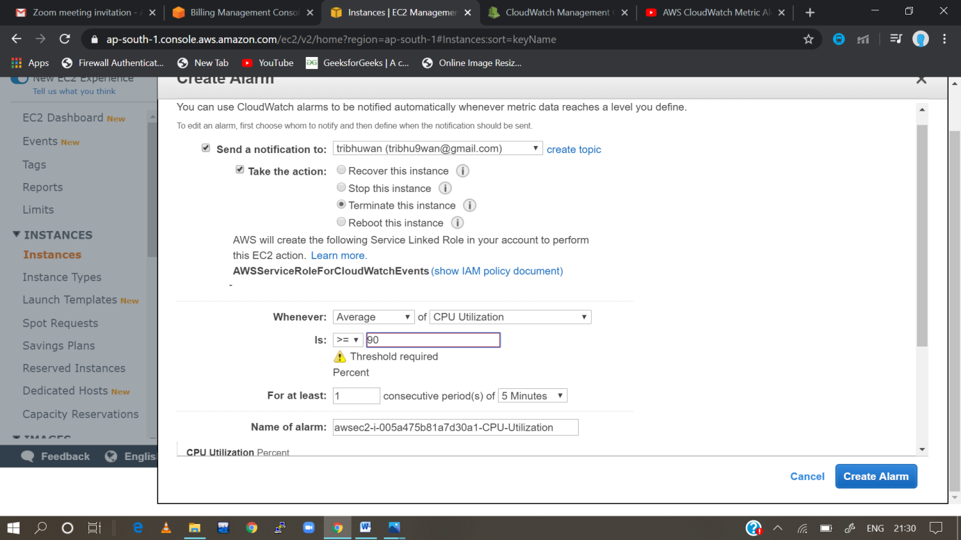

Step-5 alarm set successfully

